**Experiment 1.3**

**Student Name:   Gaurav Kumar                                UID: 22MCC20177**

**Branch:   CC-DevOps                                                        Section/Group: 1/B**

**Semester:   I                                                               Date of Performance: 05/10/2022**

**Subject Name: ADBMS                     Subject Code: 22CAP-647**

1. **Task to be done:**

Given a relation employee in the following figure:

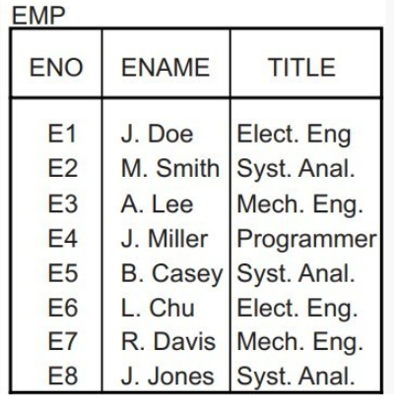

**Create table EMP**

**mysql>** create table EMP(

-> ENO varchar(5) primary key,

-> Ename varchar(30) not null,

-> TITLE varchar(30) not null;

**Query OK, 0 rows affected (0.02 sec)**

**Insert data in EMP**

**mysql>** insert into EMP values

-> ("E1","J.Doe","Elect. Eng"),

-> ("E2","M.Smith","Syst. Anal."),

-> ("E3","A.Lee","Mech. Eng"),

-> ("E4","J.Miller","programmer"),

-> ("E5","B.Casey","Syst. Anal."),

-> ("E6","L.Chu","Elect. Eng"),

-> ("E7","R.Davis","Mech. Eng"),

-> ("E8","J.Jones","Syst. Anal.");

**Query OK, 8 rows affected (0.00 sec)**

**Records: 8 Duplicates: 0 Warnings: 0**

**Let p1: TITLE< “Programmer” and p2: Title> “Programmer” be two simple predicates, Assume that character strings have an order among them, based on the alphabetical order.**

1. **Perform a horizontal fragmentation of relation EMP with respect to {p1, p2}.**

**Solution :**

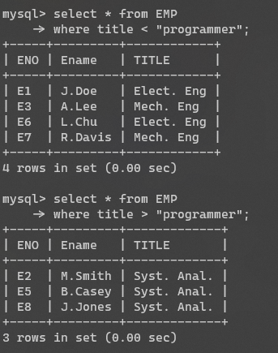

1. **Explain why the resulting fragmentation (EMP1, EMP2) does not fulfill the correctness rules of fragmentation.**

**Solution :**

The resulting fragmentation (EMP1, EMP2) does not fulfill the completeness and reconstruction of correctness rules. First the resulting fragmentation does not fulfill the completeness, because the tuple E4 in the original EMP cannot be found in the resulting fragmentation EMP1, and EMP2. Furthermore, the resulting fragmentation does not fulfill the reconstruction requirement. Using the union operation in the resulting fragmentation (EMP1, EMP2) cannot reconstruct a global relation EMP.

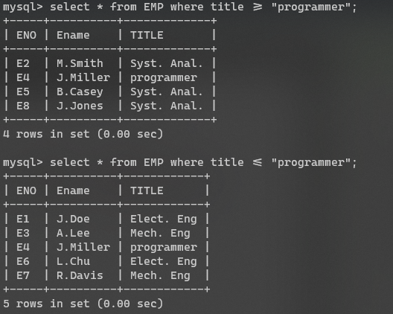

1. **Modify the predicates p1 and p2 so that they partition EMP obeying the correctness rules of fragmentaion. To do this, modify the predicates, compose all minterm predicates and deduce the corresponding implications, and then perform a horizontal fragmentation of EMP based on these minterm predicates.**

**Solution :**

Modify p1 and p2 to: P1: TITLE ≤ “Programmer” and P2: TITLE > “Programmer”

M1: TITLE ≤ “Programmer”^ TITLE > “Programmer”meaningless

M2: TITLE > “Programmer”^ TITLE > “Programmer”=> TITLE > “Programmer”

M3: TITLE ≤ “Programmer”^ TITLE ≤ “Programmer”=> TITLE ≤ “Programmer”

M4: TITLE > “Programmer”^ TITLE ≤ “Programmer”meaningless

**Finally, show that the result has completeness, reconstruction and disjointness properties**

**Completeness:** The min term predicates which are (M2: TITLE > “Programmer” and M3:TITLE ≤ “Programmer” ) are complete. The resulting fragmentation is complete. All tuples in the original relation EMP can be found in the resulting relations EMP1, EMP2.Reconstruction: The original global relation EMP can be reconstructed by the union operator in the resulting fragmentation EMP1, EMP2.

**Reconstruction:** The original global relation EMP can be reconstructed by the union operator in the resulting fragmentation EMP1, EMP2

FR = {EMP1,EMP2}

R = YRi

**Disjointness:** Because the min term predicate which are (M2: TITLE > “Programmer” and M3: TITLE ≤ “Programmer” ) are mutually exclusive. The resulting fragmentation is disjointed. No EMP1 tuple can be found in EMP2, Similarly No EMP2 tuple can be found in EMP1

1. **Learning outcomes (What I have learnt):** 
   * 1. **Fragmentation**
     2. **Horizontal Fragmentation**
     3. **Completeness**

**Evaluation Grid:**

|  |  |  |  |
| --- | --- | --- | --- |
| Sr. No. | Parameters | Marks Obtained | Maximum Marks |
| 1. | Demonstration and Performance  (Quiz) |  | 22 |
| 2. | Worksheet |  | 8 |